WTO Ministerial Conferences (MC)
The first Ministerial Conference (i.e. MC1) was held in Singapore in 1996 and the last one (MC11) was organised in Buenos Aires in 2017. All these MCs have evolved prevailing current global trading system.
The following table summarises the various Ministerial Conferences held under WTO
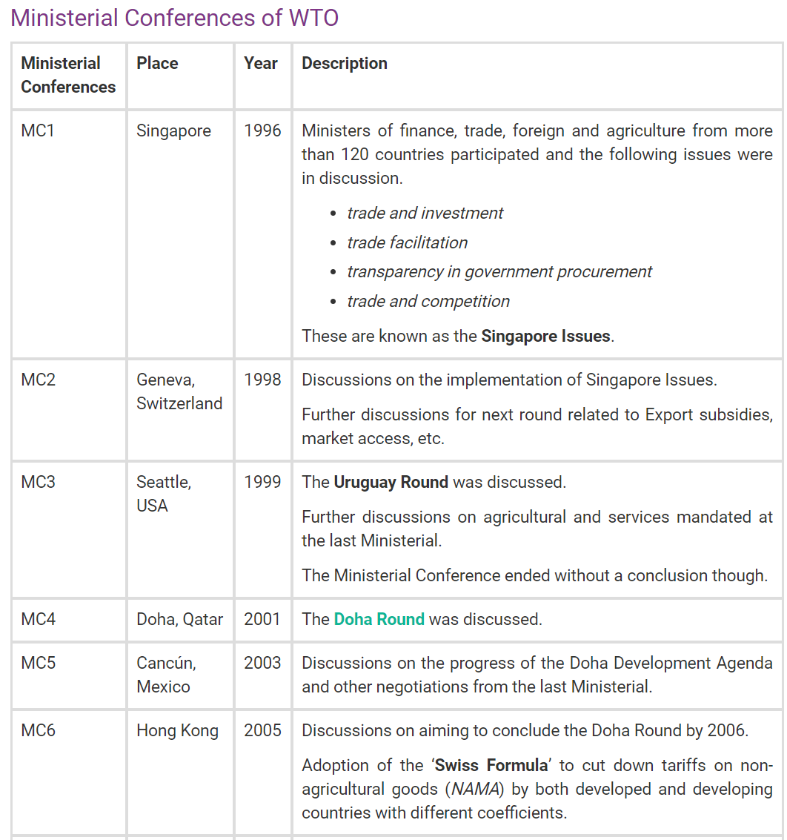
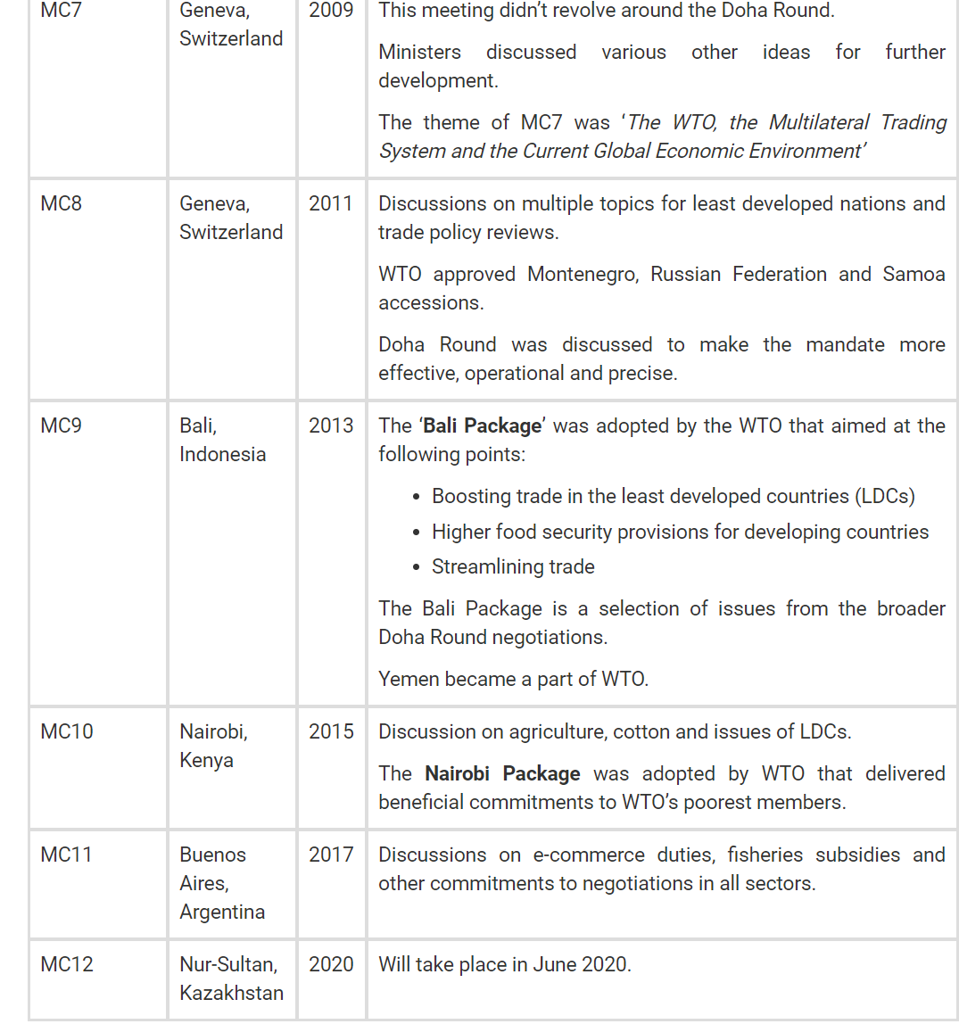Source: https://byjus.com/free-ias-prep/world-trade-organization-wto/

Here we discuss some of the major Ministerial Conferences:
- Singapore ministerial meet and ‘Singapore issues’ – 1996
The ‘Singapore issues’ term refers to areas of’
- trade and investment;
- trade and competition policy;
- trade facilitation; and
- transparency in government procurement,
These four issues have collectively come to be known as the Singapore issues in the context of the WTO, because it was at the first ministerial conference of the WTO in Singapore in 1996 that they were first brought up as possible areas on which the multilateral body could initiate negotiations.
As it can be inferred from these four areas, only ‘trade facilitation’ is directly related to trade, while other three are only indirectly related (if not unrelated) to trade. Developed countries wanted to include all these areas in negotiations. In contrast, developed countries wanted implementation of outcomes of Uruguay round. Hence, from very beginning of WTO deliberations, contradictions of interests of both developed and developing world came to surface, which continues till date.
Further, The USA and Norway were behind the push for bringing in labour standards in the WTO, but developing countries were able to get the meeting to agree that the International Labour Organisation is the competent body to do such work.
What was India’s stand?
On issues like investment and competition policy, India felt that having a multilateral agreement would be a serious impingement on the sovereign rights of countries. To an extent, of course, this is inherent in any multilateral treaty, but investment is seen as an area in which ceding sovereign rights would leave governments, particularly developing country governments, with too little room for directing investments into areas of national priority.
These were concerns that many other developing countries also share. In addition, on the specific issue of competition policy as applicable to “hardcore cartels,” India had pointed out that there was no clarity on whether these would include export cartels. The Organisation of Petroleum Exporting Countries (OPEC) is perhaps the best known example of an export cartel that rigs prices by fixing production ceilings. On the issue of transparency in government procurement, the Indian position was that while the principle is entirely acceptable, there cannot be a universal determination of what constitutes transparent procedures. On trade facilitation, India had argued that once again while the idea is unexceptionable, developing countries may not have the resources — by way of technology, or otherwise — to bring their procedures in line with those in the developed world over the short to medium term.
- Doha Ministerial meet and ‘Doha Development Agenda’ – 2001
The developed countries tried to push a lopsided agreement on Singapore Issues down the throat of developing countries, but latter successfully resisted. All this while, allegations were hurled on developed countries for ignoring developmental challenges of developing and least developed countries. This made developed countries to agree to a ‘developmental agenda’ and new round of negotiations – Doha Development Round begun at 4th ministerial meet in Doha. It is said that this was agreed to by developed countries in expectation that contents of ‘Singapore Issues’ will be agreed.
Main issues of Doha Development Round
a. Agriculture – First proposal in Qatar, in 2001, called for the end agreement to commit to substantial improvements in market access; reductions (and ultimate elimination) of all forms of export subsidies (including under Green and blue box); and substantial reductions in trade-distorting support.
The United States was asked by the EU and the developing countries, led by Brazil and India, to make a more generous offer for reducing trade-distorting domestic support for agriculture. The United States insisted that the EU and the developing countries agree to make more substantial reductions in tariffs and to limit the number of import-sensitive and ‘special products’ (AOA) that would be exempt from cuts. Import-sensitive products are of most concern to developed countries like the European Union, while developing countries are concerned with special products – those exempt from both tariff cuts and subsidy reductions because of development, food security, or livelihood considerations. Brazil emphasized reductions in trade-distorting domestic subsidies, especially by the United States (some of which it successfully challenged in the WTO U.S.-Brazil cotton dispute), while India has insisted on a large number of special products that would not be exposed to wider market opening.
b. Access to patented medicines – A major topic at the Doha ministerial regarded the WTO Agreement on Trade-Related Aspects of Intellectual Property Rights (TRIPS). The issue involves the balance of interests between the pharmaceutical companies in developed countries that held patents on medicines and the public health needs in developing countries. Before the Doha meeting, the United States claimed that the current language in TRIPS was flexible enough to address health emergencies, but other countries insisted on new language.
On 30 August 2003, WTO members reached agreement on the TRIPS and medicines issue. Voting in the General Council, member governments approved a decision that offered an interim waiver under the TRIPS Agreement allowing a member country to export pharmaceutical products made under compulsory licenses to least-developed and certain other members. It also allows members to not to allow evergreening of Patents.
c. Special and differential treatment (SDT) – SDT as a principle has been there since 1970’s in multilateral negotiations under GATT. In Doha round, members agreed that Developing and Least developed countries will continue to be eligible for a favourable treatment. However, of late developed countries are dragging their feet here too. They now claim that big developing countries like India, China, Brazil and South Africa are unreasonable in their demand and only least developed countries are rightful claimant of differential treatment. Here it is inconceivable that poor countries like India are to be treated at par with western developed world. At the December 2005 Hong Kong ministerial, members agreed to five S&D provisions for least developed countries(LDCs), including the duty-free and quota-free access.
d. Implementation issue: Developing countries claim that they have had problems with the implementation of the agreements reached in the earlier Uruguay Round because of limited capacity or lack of technical assistance. They also claim that they have not realized certain benefits that they expected from the Round, such as increased access for their textiles and apparel in developed-country markets. They seek a clarification of language relating to their interests in existing agreements.
Apart from this, there was agreement on prevention of appropriation of Traditional Knowledge of developing world by Corporations in west like Basmati Rice.
- Cancun Ministerial Meet – Abandonment of Singapore issues – 2003
At Fifth WTO Ministerial Conference, the main task was to take stock of progress in negotiations and other work under the Doha Development Agenda. With Doha Development Agenda in place it was expected that some concessions will be made on Singapore issues, but position remained entrenched as they were.
The only positive development from the point of view of trade negotiations was the creation and survival of the new developing country negotiating group, the G-20. In particular, subsequent mini-negotiations have seen the growing importance of members of the G-20 like India, Brazil and South Africa.
- Geneva Talks – 2004 – Here Singapore issues were dropped from Doha Agenda. Further it was agree to proceed in areas of agriculture, Non- Agricultural market access, Services and Trade facilitation.
- Potsdam , 2007
In June 2007, negotiations within the Doha round broke down at a conference in Potsdam, as a major impasse occurred between the USA, the EU, India and Brazil. The main disagreement was over opening up agricultural and industrial markets in various countries and how to cut rich nation farm subsidies.
- Bali Ministerial Meet and ‘Bali Package – Trade Facilitation and Peace Clause’ – 2013
In Bali, Trade facilitation was agreed to by all nations and for adjustments/adaptations to limits under Agreement on Agriculture (de minimis provisions); a ‘Peace clause’ was agreed at. Peace clause gave countries 4 year times to adjust to the limit and avoid sanctions.
Date for ratification of Bali agreement was 31 July, 2014, on which India declined to ratify unless a ‘permanent solution’ is reached. After this, in November, India – US reached understanding in which time limit of 4 years was removed and in return Trade Facilitation was agreed to by India.
Notably, in Deal at Bali, Developed countries were able to woo under developed countries on basis of a ‘Special Package’ for them directed toward Social and physical infrastructure. India as a result was isolated in all this, only South Africa extended some support to India’s stand.
Trade Facilitation requires member countries to invest in Infrastructure that facilitates Imports and exports, simplify custom procedures and remove other non-tariff barriers.
It should be noted that development of Infrastructure is already a priority for government and it is much desirable in agriculture too, as India is net exporter of agri-products. But issue was of 4 years of ‘peace clause’, which now stands removed.
‘Trade facilitation deal’ was marketed by developed countries as a progressive and much needed deal for good of all type of countries. It was said that it will boost up Global GDP by $ 1 Trillion and will add millions of new job. This argument has a little or no empirical backing and it is feared that western supplier will invade domestic markets of developing and underdeveloped countries. ‘Trade facilitation’ along with ‘special package’ is like saying that gains of developed countries will be so big, that losses of under-developed countries will be lucratively compensated by them.
- Nairobi Ministerial Meet – 2015: Nairobi meet was a huge disappointment for the developing and under developed world. Here, U.S. trade Representative unabashedly called Doha Development Agenda a dead, outdated and undesirable course. West is desperately trying to set aside development aspect of negotiations, to which it had agreed in Doha. Its focus is now on Trade Facilitation Agreement which was agreed to in Bali meet. Further, they are trying to introduce new issues (including some Singapore issues) such as Government Procurement, E-commerce, Investment, Competition policy. To this India and other developing countries took strong objection.
In the run-up to the Nairobi meeting, a large majority of developing countries led by India, China, South Africa, Indonesia, Ecuador, and Venezuela prepared the ground to ensure that the Doha Round of negotiations are not closed by the two trans-Atlantic trade elephants. They also tabled detailed proposals for a permanent solution for public stockholding programmes for food security and a special safeguard mechanism (SSM) to protect millions of resource-poor and low-income farmers from the import surges from industrialized countries.
Again, the two proposals were actively opposed by the US, which led a sustained campaign to ensure that there was neither an outcome on continuing DDA negotiations nor a deal on SSM and public stockholdings for food security.
Highlights of Nairobi outcomes:
- There was a commitment to completely eliminate subsidies for farm exports: Under the decision, developed members have committed to remove export subsidies immediately, except for a handful of agriculture products, and developing countries will do so by 2018. Developing members will keep the flexibility to cover marketing and transport costs for agriculture exports until the end of 2023, and the poorest and food-importing countries would enjoy additional time to cut export subsidies.
- Ministers also adopted a Ministerial Decision on Public Stockholding for Food Security Purposes. The decision commits members to engage constructively in finding a permanent solution to this issue. Under the Bali Ministerial Decision of 2013, developing countries are allowed to continue food stockpile programmes, which are otherwise in risk of breaching the WTO’s domestic subsidy cap, until a permanent solution is found by the 11th Ministerial Conference in 2017.
- A Ministerial Decision on a Special Safeguard Mechanism (SSM) for Developing Countries recognizes that developing members will have the right to temporarily increase tariffs in face of import surges by using an SSM. Members will continue to negotiate the mechanism in dedicated sessions of the Agriculture Committee. (This means issue is not closed and still under negotiation).
- There were other decisions of particular interests of least developing Countries. One of them is Preferential Rules of Origin. It entails that ‘Made in LDC’ products will get unrestricted access to markets of non-LDCs.
- There was affirmation that Regional Trade Agreements (RTAs) remain complementary to, not a substitute for, the multilateral trading system (WTO).
- Ministers acknowledged that members “have different views” on how to address the future of the Doha Round negotiations but noted the “strong commitment of all Members to advance negotiations on the remaining Doha issues

WTO: An Evaluation
The 164 member World Trade Organization (WTO) held its Ministerial meeting in Buenos Aires, Argentina which ended in an impasse. It is the second time that a WTO ministerial meeting ended without any positive outcome or a way forward. The first time was the meeting in Cancun, Canada in 2003. The main reason for its failure was the lack of consensus on some of the controversial issues and the US becoming more and more belligerent in its interventions, especially on questions raised by India and China and other developing countries.
It is becoming increasingly apparent that WTO, which is supposed to do the important work of trade monitoring and contribute to the effective functioning of the multilateral trading system, is increasingly becoming toothless and is succumbing to the pressure of the developed countries, especially the US.
In the past, there was a sympathetic treatment towards developing countries like India, which got special and differential treatment at the WTO which gave them more time to comply with the WTO rules, but now the US has begun to question this special treatment because countries like India and China are considered large Emerging Economies due to the giant size of their population and hence GDP.
WTO, however, still remains the primary instrument governing a rules-based world trading system.

The Doha Round
The Doha Ministerial Declaration provided the mandate for the negotiations, including on following subjects:
  - Agriculture: More market access, eliminating export subsidies, reducing distorting domestic support, sorting out a range of developing country issues, and dealing with non-trade concerns such as food security and rural development.
  - Non-agricultural market access (NAMA): To reduce or as appropriate eliminate tariffs, including the reduction or elimination of high tariffs, tariff peaks and tariff escalation (higher tariffs protecting processing, lower tariffs on raw materials) as well as non-tariff barriers, in particular on products of export interest to developing countries.
  - Services: To improve market access and to strengthen the rules.
    - Each government has the right to decide which sectors it wants to open to foreign companies and to what extent, including any restrictions on foreign ownership.
    - Unlike in agriculture and NAMA, the services negotiations are not based on a “modalities” text. They are being conducted essentially on two tracks:
    - (a) bilateral and/or plurilateral (involving only some WTO members) negotiations
    - (b) multilateral negotiations among all WTO members to establish any necessary rules and disciplines
  - Trade facilitation: To ease customs procedures and to facilitate the movement, release and clearance of goods. This is an important addition to the overall negotiation since it would cut bureaucracy and corruption in customs procedures and would speed up trade and make it cheaper.
  - Rules: These cover anti-dumping, subsidies and countervailing measures, fisheries subsidies, and regional trade agreements.
    - “Clarifying and improving disciplines” under the Anti-Dumping and Subsidies agreements and to “clarify and improve WTO disciplines on ﬁsheries subsidies, taking into account the importance of this sector to developing countries.
  - The environment: These are the first signiﬁcant negotiations on trade and the environment in the GATT/ WTO. They have two key components:
    - Freer trade in environmental goods – Products that WTO members have proposed include: wind turbines, carbon capture and storage technologies, solar panels.
    - Environmental agreements – Improving collaboration with the secretariats of multilateral environmental agreements and establishing more coherence between trade and environmental rules.
  - Geographical indications (GI): multilateral register for wines and spirits
    - Geographical indications are place names (in some countries also words associated with a place) used to identify products that come from these places and have specific characteristics (for example, “Champagne”, “Tequila” or “Roquefort”). Under the TRIPS Agreement, all geographical indications have to be protected at least to avoid misleading the public and to prevent unfair competition.
    - This is the only intellectual property issue that is deﬁnitely part of the Doha negotiations.
    - The objective is to “facilitate” the protection of wines and spirits in participating countries. The talks began in 1997 and were built into the Doha Round in 2001.
  - Other intellectual property issues: Some members want negotiations on two other subjects and to link these to the register for wines and spirits. Other members disagree. Following these two topics are discussed:
    - GI “extension”- Extending the higher level of protection for geographical indications beyond wines and spirits.
    - Biopiracy, benefit sharing and traditional knowledge
  - Dispute settlement: To improve and clarify the Dispute Settlement Understanding, the WTO agreement dealing with legal disputes. These negotiations take place in special sessions of the Dispute Settlement Body (DSB).
- With Doha Round seemingly adrift (directionless), the global Great Recession that began in the second half of 2008 led to fears that the world may face a wave of protectionism that the WTO would be powerless to prevent. Negotiations continued after the 2008 global financial crisis with low expectations.
- The 2013 Ministerial Conference (MC9) in Bali, Indonesia, delivered a significant achievement, the first multilateral agreement since the creation of the WTO. This was the Trade Facilitation Agreement (TFA), which aims to speed up customs procedures and make trade easier, faster, and cheaper. The TFA was only a small slice of the larger Doha agenda, but the successful deal was a cause for optimism. The talks also reached an interim agreement (a peace clause) on “public stockholding” continuing exceptions that allow developing countries to stockpile agricultural products to protect against food shortages.
- 2015 Ministerial Conference Nairobi, Kenya (MC10) focused on a selected number of issues that are part of the Doha Development Agenda (DDA). Agreement was reached on following DDA issues:
  - Stopping the use of subsidies and other schemes unfairly supporting agricultural exports
  - Ensuring that food aid for developing countries is given in a way which does not distort local markets
  - Seeking to simplify the conditions that exporters from the poorest countries have to meet, so that their products benefit from trade agreements (so-called rules of origin)
  - Giving more opportunities for businesses from the poorest countries to provide services in the WTO's 164 member countries
- However, for many observers, Nairobi signalled the end of the Doha talks, a sentiment that intensified after the 2016 election of Trump. President Trump made clear his preference for bilateral trade when he withdrew from the 12-country Trans-Pacific Partnership (TPP) shortly after taking office.
- In 2017 Ministerial Conference Buenos Aires (MC11), USA reflected the skepticism toward multilateralism when it blocked agreement on a draft ministerial declaration that would have “reaffirmed the centrality of the multilateral trading system and the development dimension of the organisation’s work.”
  - Meanwhile, India, which has repeatedly threatened to block WTO agreements (including the Trade Facilitation Agreement) unless WTO members conceded to its demands on public stockholding for food security. India also toughened its stand on new issues including e-commerce and investment facilitation.
  - In the end, it was a relief to many that the United States did not actively seek to dismantle the WTO—as some had feared. But giving up its traditional leadership role could lead to a similar result, only more slowly.
After 14 years of talks, in 2015, members of the World Trade Organization have effectively ended the Doha round of negotiations. That was not unexpected given how fruitless these discussions have been. Now, world leaders need to think a new about the global trading system. Countries had hoped that the talks, named after the capital of Qatar, where they began in late 2001, would substantially lower trade barriers, contribute to development in poor nations and tackle difficult issues like agricultural subsidies that were not resolved in earlier pacts, like the General Agreement on Tariffs and Trade.
Failure to achieve this ambitious agenda has undermined the credibility of the multilateral trading system and hurt the least-developed countries, which are desperate to export more of their goods to richer countries. At a meeting of the W.T.O. in mid-December in Nairobi, trade ministers from more than 160 countries failed to agree that they should keep the negotiations going. In recent years, it became clear that the talks, which were originally supposed to conclude in 2005, were paralyzed because neither developed economies like the United States and the European Union nor developing countries like China and India were willing or able to make fundamental concessions.
At the start of the Doha round, American and European officials committed to producing a trade agreement that would promote development in poorer countries without asking them to reduce import barriers to the same extent as industrialized nations. But as developing countries, particularly China, began exporting far more than they were importing, wealthier countries started demanding that they also lower import barriers and cut subsidies to their farmers. Not surprisingly, China and India refused, insisting on sticking with the original principles.
Many countries have been so frustrated by the Doha stalemate that they have been negotiating bilateral and regional trade deals. For example, the United States recently concluded the Trans-Pacific Partnership with Japan, Vietnam and nine other countries. America and the European Union are also negotiating the Transatlantic Trade and Investment Partnership. China, which is not part of the Trans-Pacific Partnership, has signed many bilateral and regional agreements and proposed a 16-country trade deal that would include India and Japan.
Regional agreements can be useful if done right, but they threaten to segregate the world into overlapping trading blocs with different rules in areas like labor rights, environmental protection and access to medicines. And most such pacts — in which countries agree to eliminate tariffs for products made within the trading bloc — do not include the world’s least-developed countries, like Bangladesh and Ethiopia.
Another approach is to pursue more limited pacts that include many or all members of the World Trade Organization. A good example is the Trade Facilitation Agreement reached in December 2013 in which all W.T.O. members agreed to improve their customs departments, border crossings and ports. Under that agreement, less-developed countries will receive aid and technical expertise to help them upgrade their trading systems. Another worthwhile effort that began in 2014 with 14 W.T.O. members, including the United States, China and the European Union, is designed to eliminate tariffs on environmental goods like solar panels and wind turbines.
While pacts focusing on specific issues are easier to negotiate, they can’t cover the broader issues that countries, rich and poor, have to wrestle with. Trade increasingly determines how governments set social policies and labour conditions within domestic markets, and, of course, affects the future of the environment locally as well as globally. The Doha talks may be at a dead end but there has to be a place for global trade pacts that encourage development and sustainable economic growth.
India and WTO
India is the founding member of the WTO. India was in favour of multilateral trade approach. It enjoys MFN status and allows the same status to all other trading partners. India has joined the WTO in order to integrate the domestic economy with the world economy. Our country had been depending on export and import for coping with the domestic needs of technology, machinery and consumer goods. In the absence of WTO membership, we had to negotiate separately with each and every country and be at a disadvantageous position. Country to country negotiations every year were not only time consuming but also there used to be arm twisting negotiations with developed countries. Thus India joined the WTO membership. India benefited from WTO provisions 274 in which some areas like –
Firstly, by reducing tariff rates on raw materials components and, capital goods, it was able to import more for meeting her developmental requirements.
Secondly, as India is a founder member of WTO with wide membership of the organisation, India get market access in several countries without any bilateral trade agreements.
Thirdly, advanced technology would be obtained at low cost.
Fourthly, because of wide arrangement for resolving trade disputes under WTO, India would be in a better position to get quick redressal of the trade disputes, if any.
Fifthly, the scope of creating more job would be expanded. Sixthly, the Indian exporters have deficient market information, this can be removed by the help of WTO and country can get wider market information, and
Finally, due to increasing competition and exposure the competitive edge and productivity of Indian industry will improve.
In order to achieve the gains from WTO the government of India has announced the Export-Import policy 1992-1997 to liberalize trade and boost domestic manufacturing sector. The ministry of commerce of the Government of India expects that by WTO India would benefit by creating 10 million additional jobs annually and India's market share in world exports would improve.
Issues of India at WTO
- Public Distribution system: At the Buenos Aires meeting, India sought a permanent solution to its public stock holding issue because currently it is under the peace clause put in place at the Bali Ministerial meeting of 2013 by which India continues to undertake stockholding of foodgrains equal to 10 per cent of the value of its food production for meeting its food security requirement. But a permanent solution which was promised has not been delivered at the Buenos Aires 11th Ministerial Conference (MC11), mainly because the US blocked it.

- Agriculture: In agriculture, India and China have opposed the huge production related price distorting subsidies given by the developed countries like the US and the EU to their farmers which make their products cheaper as compared to produce from developing countries, making it harder for them to compete with the advanced countries. US alone gives around USD 150 billion in direct subsidies to farmers which come under the Green Box, according to the rules of GATT, and hence allowed. India’s MSP is considered trade distorting and comes under the Amber Box and India is mandated to reduce it. But this issue of high subsidies given by developed countries to their agriculture was not addressed even though it has been raised in previous meetings of the WTO. In general, the US refused to have any dialogue on agricultural reforms.

- E-commerce: Other issues which never cropped up before were also raised like the freeing of e-commerce and investment facilitation by a group of countries. China proposed freeing of e-commerce, but India rightly objected. China wants to remove all duties on e-commerce — something which is not feasible in India’s case because India’s digital penetration is not as deep as China’s and freeing of e-commerce will not help the MSMEs as they will not be able to compete with countries with deeper internet penetration which lead to their having better access to international markets.

- Investment Facilitation: Regarding investment facilitation, India has got its own new model investment code which does not allow multinational companies to take the government to international courts before it has taken recourse to the domestic dispute settlement bodies for a period of at least five years. This is because, in the past, the government of India has been taken to international arbitration courts on multiple occasions.

- In the case of fisheries also, China and India did not make commitments to eliminate fisheries subsidies on ‘illegal fishing’ because of the livelihood of large number of fishermen is involved.

- Domestic Content Requirement in Solar Panel: India, in 2016, lost case to US in WTO’s dispute resolution body. India has prescribed ‘domestic content requirement’ for procurement of Solar cells/panels for its target of installing 100 GW of solar power by 2022. Under this some (about 5%) procurement was reserved to be bought from Indian vendors, to promote indigenous industry. US alleged that this is against principles of Non Discrimination and National Treatment. In 2013, the U.S. brought a complaint before the WTO arguing that the domestic content requirement imposed under India’s national solar programme is in violation of the global trading rules. Specifically, it said, India has violated its “national treatment” obligation by unfavourably discriminating against imported solar cells and modules. In other words, India was discriminating between solar cells and modules which were otherwise identical on the basis of the national ‘origin’ of the cells and modules, a clear violation of its trade commitment. India principally relied on the ‘government procurement’ justification, which permitted countries to derogate from their national treatment obligation provided that the measure was related to “the procurement by governmental agencies of products purchased for governmental purposes and not with a view to commercial resale or use in production of goods for commercial sale”. India also argued that the measure was justified under the general exceptions since it was necessary to secure compliance with its domestic and international law obligations relating to ecologically sustainable development and climate change. The panel, in its 140-page report, examined in detail the submission of the parties and rightly concluded that India, by imposing a mandatory domestic content requirement, had violated its national treatment obligation.

- India, in 2019, won a major trade dispute against the US at the World Trade Organization, with a dispute settlement panel pronouncing that subsidies and mandatory local content requirements instituted by eight American states breached global trade rules. In a significant 100-page report, the three-member panel largely upheld India’s claims that subsidies and local content requirement in 11 renewable energy programmes in eight US states violated core global trade rules. The panel also asked the US to ensure that these states are in conformity with trade rules. India had claimed that the “domestic content requirements and subsidies instituted by the governments of the states of Washington, California, Montana, Massachusetts, Connecticut, Michigan, Delaware and Minnesota in the energy sector" violated several provisions of the Trade-Related Investment Measures (TRIMs) Agreement and Subsidies and Countervailing Measures Agreement. The panel urged the US to bring the eight states in conformity with US obligations of “national treatment".
The Doha Development Agenda, which the Indian government has been keen to promote and which is based on multilateralism, has been put on hold much to the chagrin of many developing countries comprising the Group of 33.
So what is it that the WTO has achieved? It has become only a dispute settlement body and even that role has been blocked by the US as it has refused to participate in the nomination of judges to the appellate body, creating a paralysis in the WTO’s dispute settlement system. Members are usually appointed by consensus and the US is an important member.
Throughout its existence, the WTO has been dominated by the developed countries, with US playing an important role. From supporting trade and investment liberalisation in the world and insisting on tariff reductions for prying open developing country markets, the US has now turned protectionist. It blocked the Trans Pacific Partnership Agreement and wants to renegotiate the North Atlantic Free Trade Agreement with Canada and Mexico in a bid to realise Trump’s goal of America First. China has emerged as a supporter of globalisation and free trade as it still remains the biggest exporter in the world.
India on the other hand has to compete with all the members of ASEAN and others around the world in increasing its share of global trade. It is promoting its own free trading arrangement with its immediate neighbours. It already has FTAs with a number of countries and is a member of several other regional groupings. If it left the WTO — no great harm would come to it in the areas of trade and investment. It will be independent of the rules of public stockholding restrictions which are unjust towards the large number of poor in India needing food security. It will be able to undertake reforms at its own pace and address the needs of the poor farmers and small and micro enterprises. India could have its own agenda of duty reduction on various sensitive items because it too like the US is interested in Make in India policy which has to give priority to its own industries first.

